Quiz on Boysen & Kybett Ch. 1 and 2
28Jul24 BR

Quiz Instructions
6 multiple choice questions based on these 4 drawings. You can use your books and notes, but I hope you don't need them, and this is relatively quick and painless.
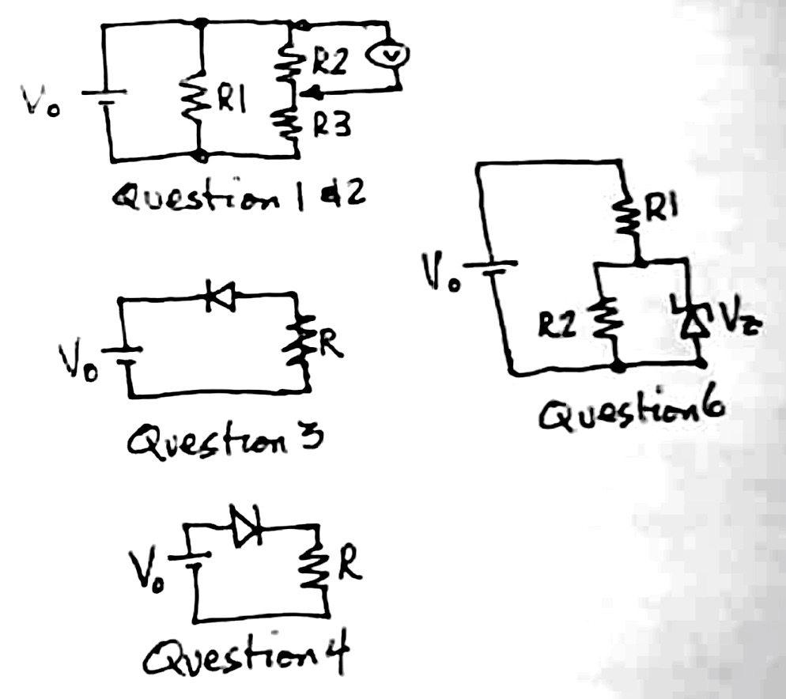
Note: this is a timed quiz. You may check the remaining time you have at any point while taking the quiz by pressing the keyboard combination SHIFT, ALT, and T...

Question 1
What does voltmeter V read in Figure 1?
- Vo*R2/(R2+R3)
- Vo*R1(R2+R2)/(R1+R2+R3)
- Vo*R2/(R1+R2+R3)
- Vo*R3/(R1+R2+R3)
- Need a second equation for the second loop

Question 2
Replace R2 in Figure 1 with a capacitor C. Was is V now across the capacitor (in steady-state)?
- 0
- Vo *Zc/(R1+Zc+R3)
- Vo/2
- Vo
- Need another equation for the second loop

Question 3
For the circuit in Fig. 3, what are Vr and Vd, the voltage across the resistor and Si rectifier diode respectively (assuming Vo > Vf=0.7V)?
- Vd = 0V, Vr = Vo
- Vd = 0.7V, Vr = Vo-0.7V
- Vd = Vo-0.7V, Vr = 0.7V
- Vd = Vo, Vr = 0

Question 4
For the circuit in Fig. 4, what are Vr and Vd, the voltage across the resistor and diode respectively (assuming Vo > Vf)?
- Vd = 0V, Vr = Vo
- Vd = 0.7V, Vr = Vo-0.7V
- Vd = Vo-0.7V, Vr = 0.7V
- Vd = Vo, Vr = 0V

Question 5
The sum of the voltages around any circuit (loop) is:
- always zero
- the sum of the active sources in the loop
- ideally zero, but real components may lead to small discrepancies
- depends on what components are in the loop

Question 6
Figure 6 is equivalent to Fig. 2.30 in your book (the light bulb is equivalent to R2). Imagine the light bulb burns out (R2 -> infinity). How does the current through R1 and the Zener diode change?
- IR1 decreases and IZd increases
- IR1 decreases and IZd stays the same
- IR1 decreases and IZd decreases
- IR1 stays the same and IZd increases
- IR1 stays the same and IZd decreases

Solutions
- A
- D
- D
- B
- A
- D

